Curriculum Overview for RECEPTION – Early Learning Goals

Personal, Social &  Making Relationships:  Children play co-operatively, taking turns with others.  They take account of one another’s ideas about how to organise their activity.  They show sensitivity to others’ needs and feelings, and form positive relationships with adults and other children  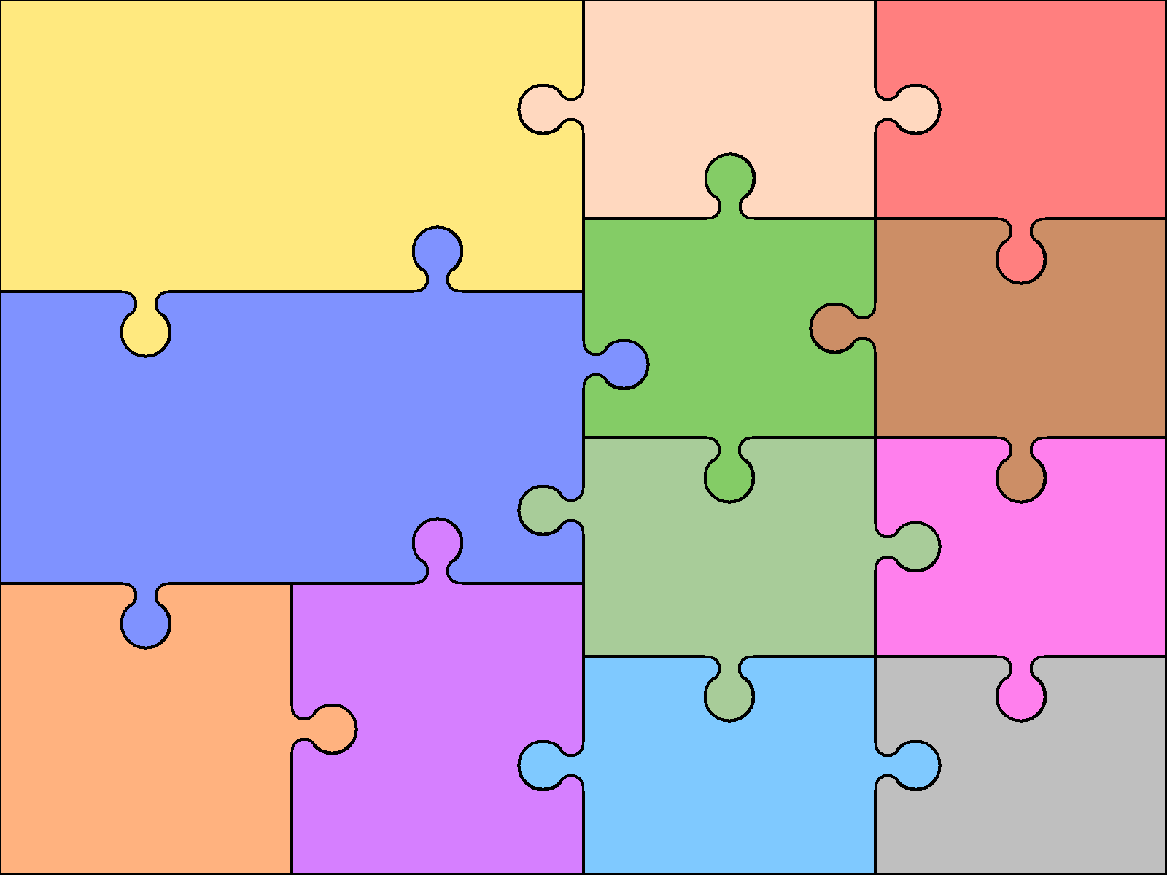 | Emotional Development  Self-confidence & self-awareness:  Children are confident to try new activities, and say why they like some activities more than others.  They are confident to speak in a familiar group, will talk about their ideas, and will choose the resources they need for their chosen activities.  They say when they do or don’t need help. |  | Managing feelings & behaviour:  Children talk about how they and others show feelings, talk about their own and others’ behaviour,  and its consequences,  and know that some  behaviour is unacceptable.  They work as part of a group or class, and understand and follow the rules.  They adjust their behaviour to different situations, and take  changes of routine in  their stride. | .  The 4children website has designed a document to support parents called, ‘What to expect, when?’ It provides a further breakdown of the skills we learn in the Foundation Stage, you can reach this by clicking on this link.  Your child will be developing these skills as they aspire to reach the Early Learning Goals, through exciting experiences in Reception. | EARLY LEARNING GOALS  These goals have been taken from the ‘Development Matters in the Early Years Foundation Stage (EYFS)’ 2012 document.  As stated in this document it is  important to remember that, ‘Children develop at their own rates, and in their own ways.’
 |  |  |  | English  Reading:  Children read and understand simple sentences.  They use phonic knowledge to decode  regular words and read them aloud  accurately.  They also read some common irregular  words.  They demonstrate understanding when talking with  others about what they have read. | English  Writing:  Children use their phonic knowledge to write words in  ways which match their spoken sounds.  They also write some irregular common words.  They write simple sentences which can be read by  themselves and others.  Some words are spelt correctly and others are  phonetically plausible.
Communication &  Listening & Attention:  Children listen attentively in a range of situations.  They listen to stories, accurately anticipating key events and respond to what they hear with relevant comments, questions or actions.  They give their attention to what others say and respond appropriately, while  engaged in another activity. | Language  Speaking:  Children express themselves effectively, showing awareness of listeners’ needs.  They use past, present and future forms accurately when talking about events that have happened or are to happen in the future.  They develop their own  narratives and  explanations by connecting ideas or events |  | Understanding:  Children follow instructions involving several ideas or actions.  They answer ‘how’ and ‘why’ questions about their experiences and in response to stories or events.
 |  |  |  | Mathematics  Numbers:  Children count reliably with numbers from one to 20,  - place them in order and  - say which number is one more or one less  than a given number.  Using quantities and objects, they add and  subtract two single-digit numbers and  count on or back to find the answer.  They solve problems, including doubling, halving and  sharing. | Mathematics  Shape, Space & Measures:  Children use everyday language to talk about size,  weight, capacity, position, distance, time and  money to compare quantities and objects  and to solve problems.  They recognise, create and describe patterns. They explore characteristics of everyday objects and shapes and use mathematical language to describe them.
Physical Development  Moving & Handling:  Children show good control and co-ordination in large and small movements.  They move confidently in a range of ways, safely negotiating space.  They handle equipment and tools effectively, including pencils for writing.  Health & Self-care:  Children know the importance for good health of physical exercise, and a healthy diet, and talk about  ways to keep healthy and safe.  They manage their own basic hygiene and personal needs successfully, including dressing and going to the toilet independently. |  | Expressive Arts and Design  Exploring & using media & materials:  Children sing songs, make music and dance, and experiment with ways of changing them.  They safely use and explore a variety of materials, tools and techniques, experimenting with colour, design, texture, form  and function.  Being imaginative:  Children use what they have learnt  about media and materials in original ways,  thinking about uses and purposes.  They represent their own ideas, thoughts and  feelings through design and technology, art,  music, dance, role play and stories.
 |  |  |  | Understanding  People & Communities:  Children talk about past and present events in their own lives and in the lives of family members.  They know that other children don’t always enjoy the same things, and are sensitive to this.  They know about similarities and differences between themselves and others, and among families, communities and traditions.  Technology:  Children recognise that a range of technology is used in places such as homes and schools.  They select and use technology for particular purposes. | the World:  The World:  Children know about similarities and differences in relation to places, objects, materials and  living things.  They talk about the features of their own  immediate environment and how environments might vary from one another.  They make observations of animals and plants and explain why some things occur, and talk about changes.

